BIKE SALES ANALYSIS

SETTING UP

Create database project;
Use project;

Select * from brands;
Select * from categories;
Select * from customer;
Select * from order_items;
Select * from orders;
Select * from products;
Select * from staffs;
Select * from stocks;
Select * from stores;

DATA CLEANING

SELECT COUNT(*) FROM BRANDS;
SELECT COUNT(*) FROM CATEGORIES;
SELECT COUNT(*) FROM CUSTOMER;
SELECT COUNT(*) FROM ORDER_ITEMS;
SELECT COUNT(*) FROM ORDERS;
SELECT COUNT(*) FROM PRODUCTS;
SELECT COUNT(*) FROM STAFFS;
SELECT COUNT(*) FROM STOCKS;
SELECT COUNT(*) FROM STORES;

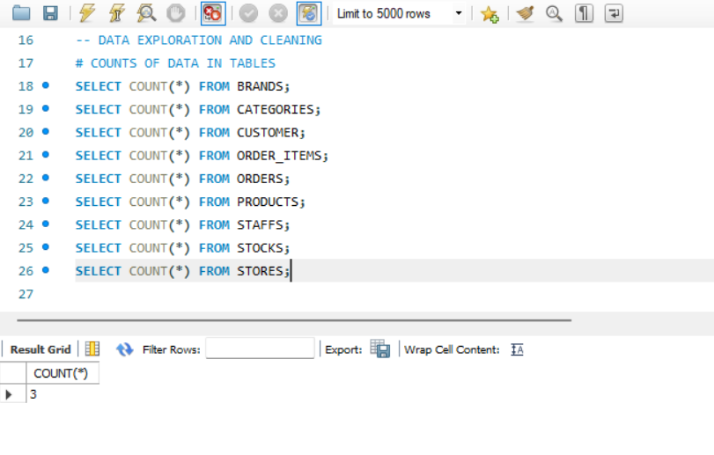

CATEGORY COUNT

SELECT DISTINCT BRAND_ID, BRAND_NAME FROM BRANDS;
SELECT DISTINCT CATEGORY_NAME , CATEGORY_ID FROM CATEGORIES;
SELECT DISTINCT PRODUCT_ID, PRODUCT_NAME FROM PRODUCTS;

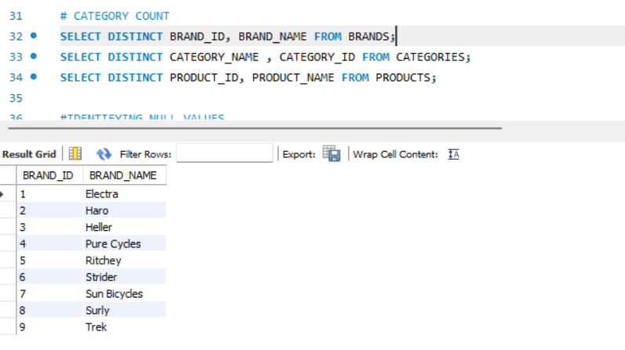

IDENTIFYING NULL VALUES

SELECT * FROM CUSTOMER
WHERE
Customer_Id IS NULL OR First_Name IS NULL OR Last_Name IS NULL OR Phone IS NULL OR Email IS NULL OR Street IS NULL OR City IS NULL OR State IS NULL OR Zip_Code IS NULL;
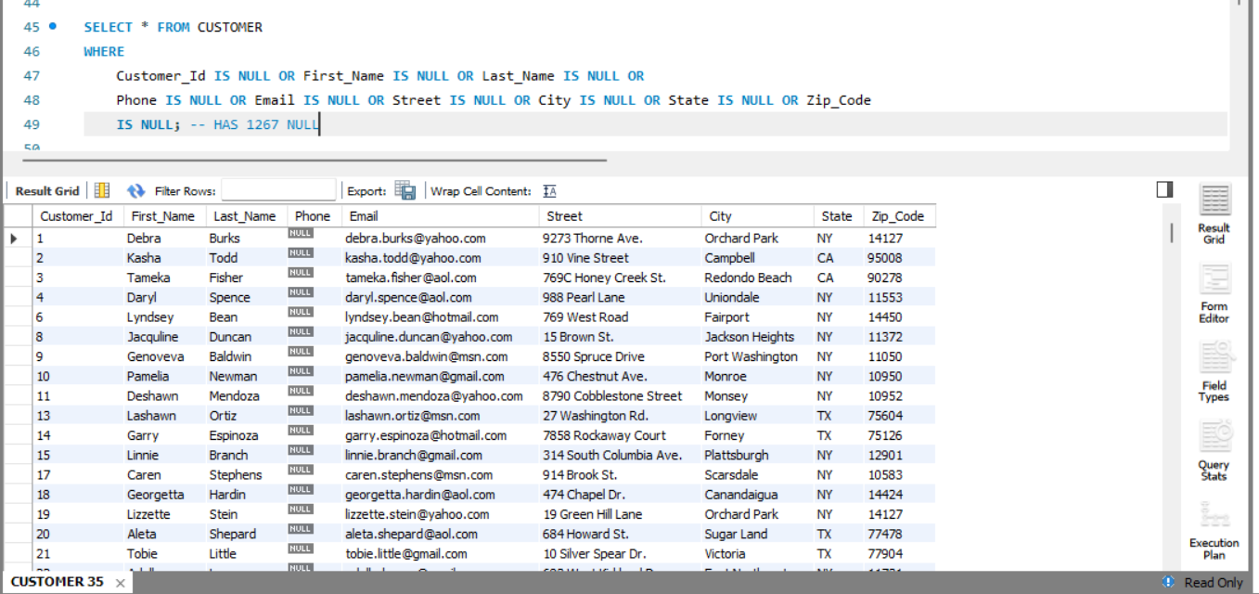

SELECT * FROM ORDERS
WHERE Order_Id IS NULL OR Customer_Id IS NULL OR Order_Status IS NULL OR
Order_Date IS NULL OR Required_Date IS NULL OR Shipped_Date IS NULL OR Store_Id IS NULL OR Staff_Id IS NULL;

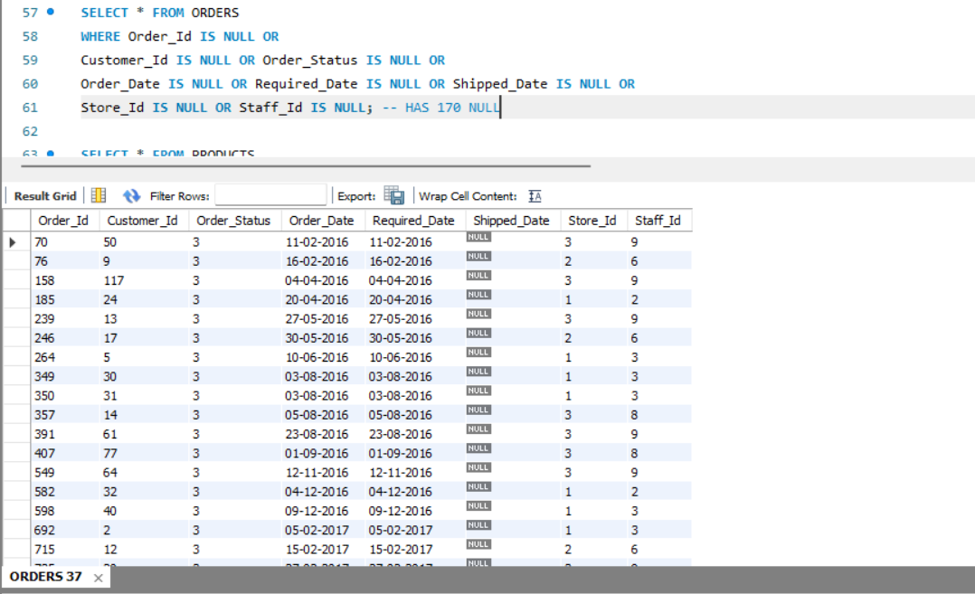

IDENTIFYING DUPLICATES

SELECT *, COUNT(*)
FROM Brands
GROUP BY
Brand_Id, Brand_Name
Having count(*) > 1;

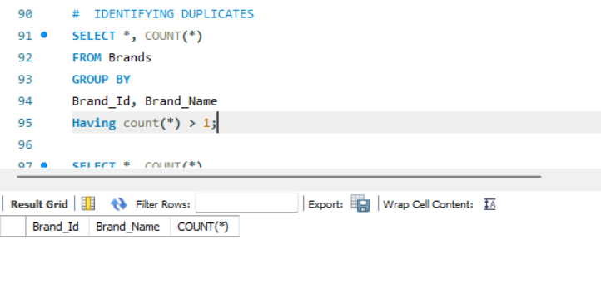

TOTAL ORDERS

SELECT COUNT(*) AS Total_orders
FROM orders;

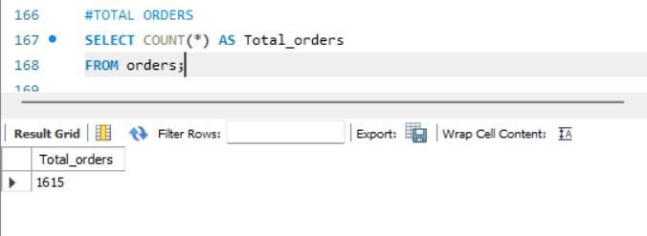

TOTAL CUSTOMERS

SELECT COUNT(*) AS total_customers
FROM customer;
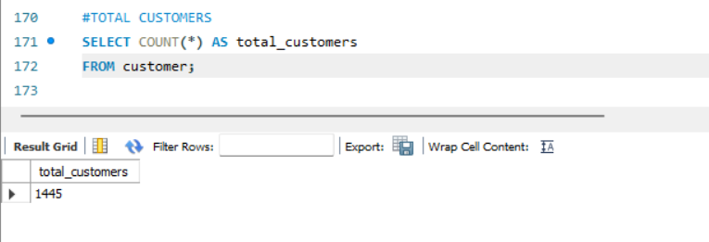

TOTAL REVENUE

SELECT ROUND(SUM(quantity * list_price), 2) AS total_revenue
FROM order_items;

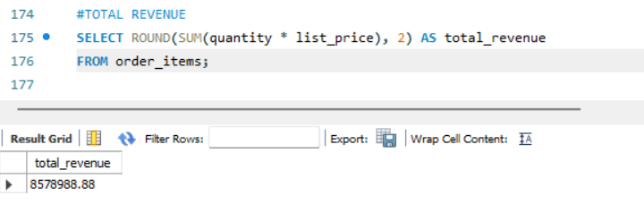

AFTER 2015

SELECT * FROM orders
WHERE order_date > '2015-01-01';
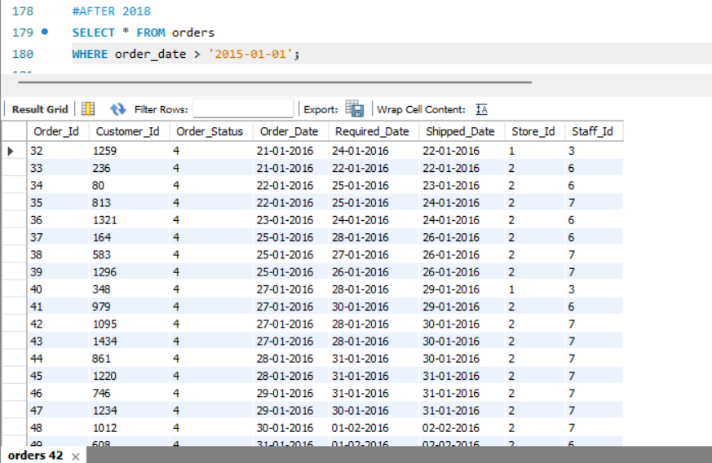

TOP 5 EXPENSIVE PRODUCTS

SELECT product_name, list_price
FROM products
ORDER BY list_price DESC
LIMIT 5;
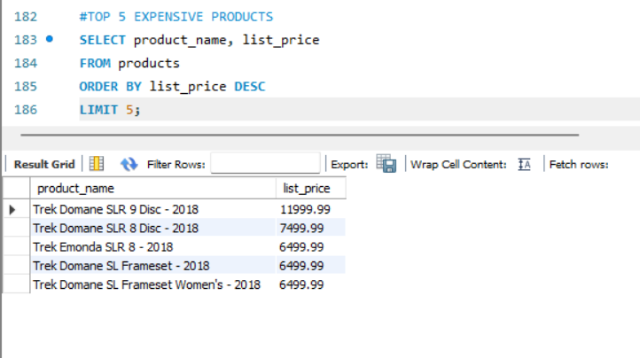

AVERAGE PRODUCT PRICE

SELECT ROUND(AVG(list_price), 2) AS avg_price
FROM products;
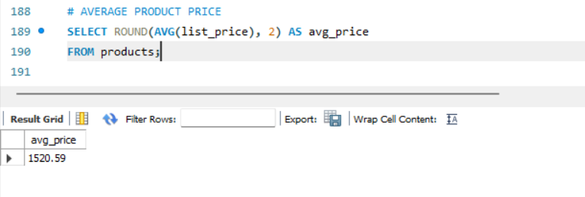

CUSTOMERS PER CITY

SELECT city, COUNT(*) AS total_customers
FROM customer
GROUP BY city;
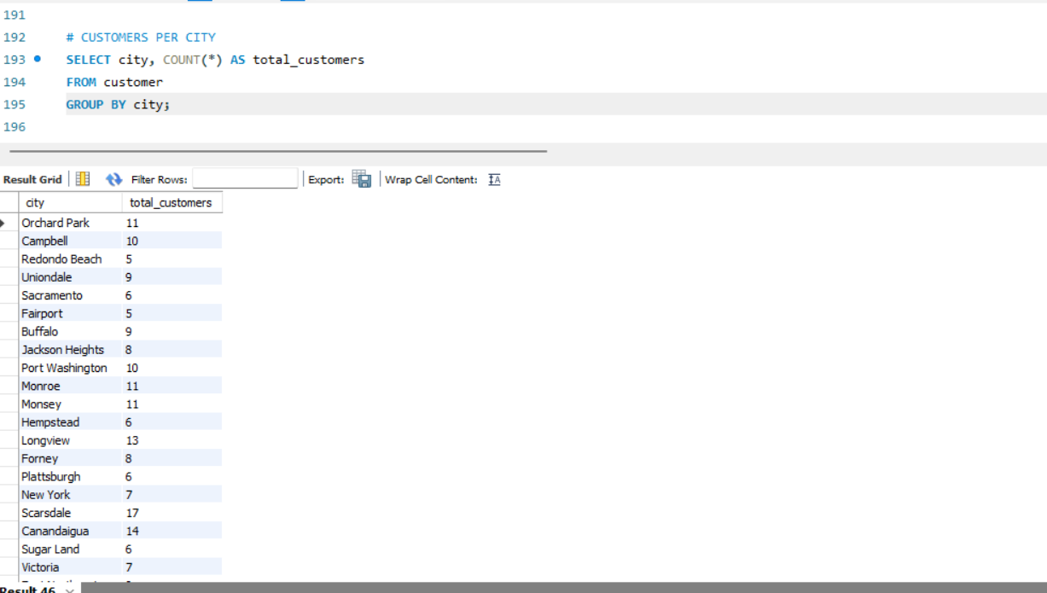

ORDERS PER CUSTOMER

SELECT customer_id, COUNT(*) AS total_orders
FROM orders
GROUP BY customer_id;

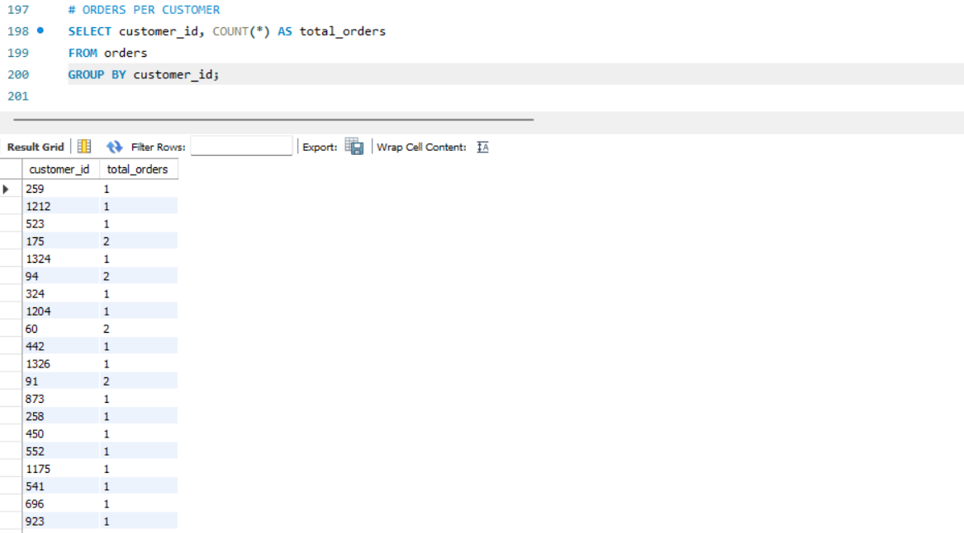

PRODUCTS PER CATEGORY

SELECT category_id, COUNT(*) AS total_products
FROM products
GROUP BY category_id;

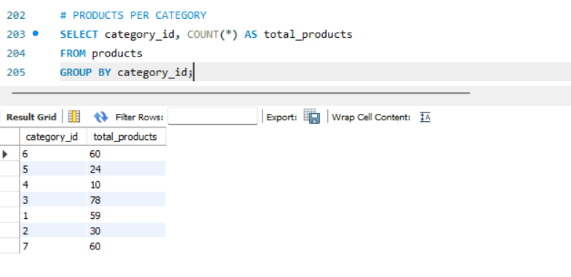

SALES PER PRODUCT

SELECT
p.product_name,
ROUND(SUM(oi.quantity * oi.list_price), 2) AS total_sales
FROM order_items oi
JOIN products p
ON oi.product_id = p.product_id
GROUP BY p.product_id, p.product_name
ORDER BY total_sales DESC;

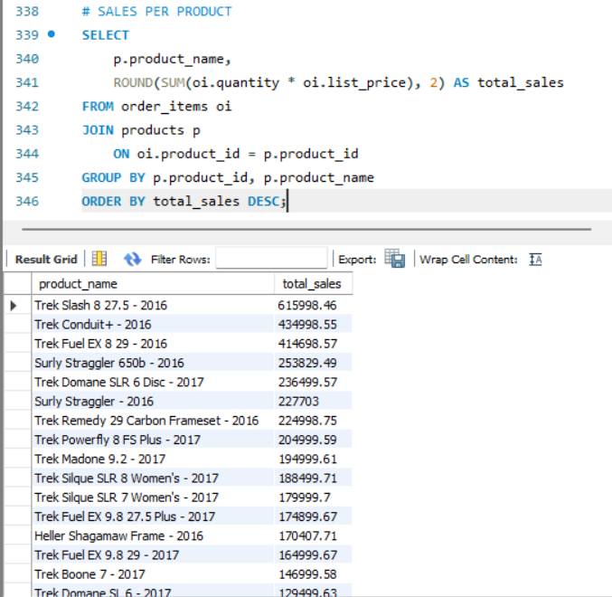

ORDERS WITH CUSTOMER NAMES

SELECT o.order_id, c.first_name, c.last_name
FROM orders o
JOIN customer c
ON o.customer_id = c.customer_id;

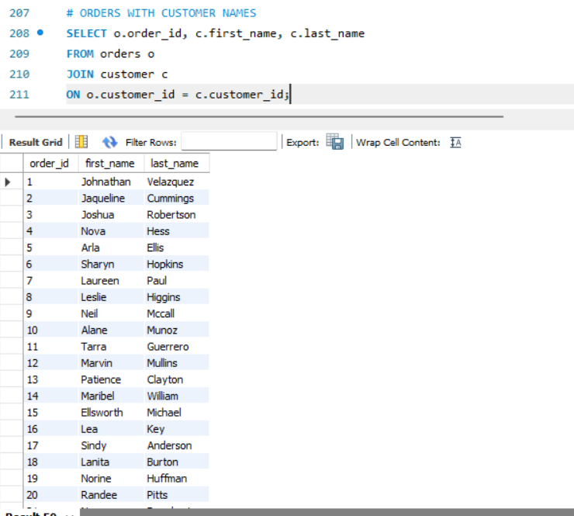

PRODUCTS WITH CATEGORY NAME

SELECT p.product_name, c.category_name
FROM products p
JOIN categories c
ON p.category_id = c.category_id;

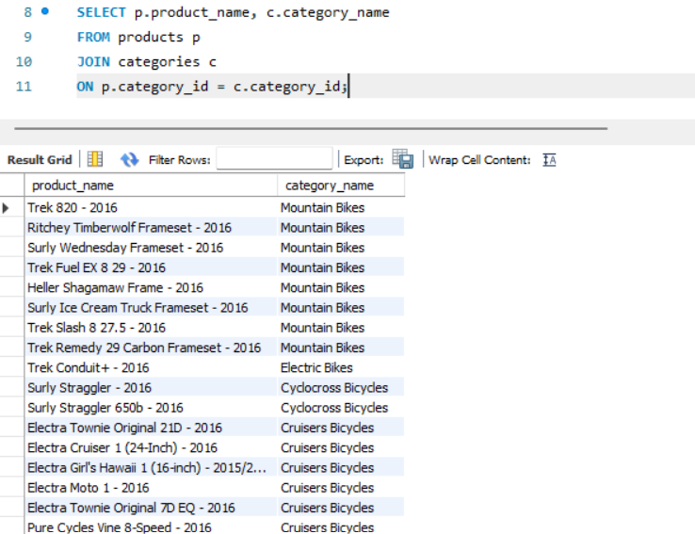

CUSTOMERS WHO NEVER ORDERED

SELECT * FROM customer
WHERE customer_id NOT IN (
SELECT customer_id FROM orders);

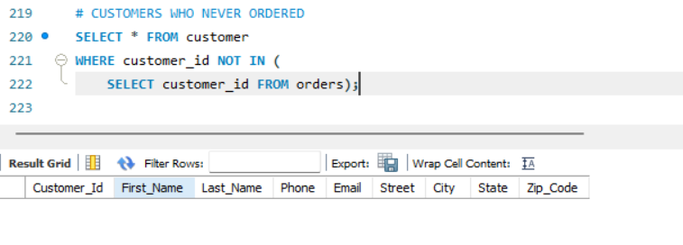

UNIQUE CUSTOMER IN DATASET

SELECT COUNT(DISTINCT customer_id) AS UNIQUE_CUSTOMERS FROM customer;

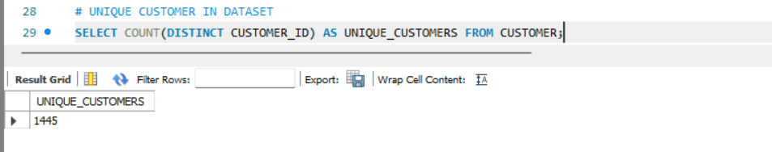

REVENUE OVER TIME

SELECT
o.order_date,
ROUND(SUM(oi.quantity * oi.list_price), 2) AS revenue
FROM orders o
JOIN order_items oi ON o.order_id = oi.order_id
GROUP BY o.order_date
ORDER BY o.order_date;

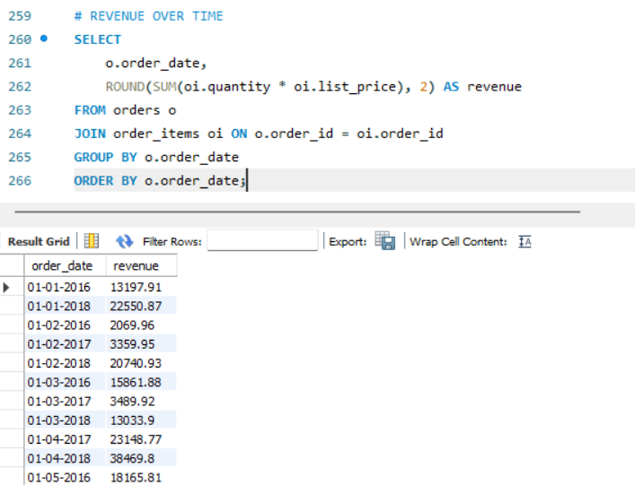

REVENUE BY STORE

SELECT
s.store_name,
ROUND(SUM(oi.quantity * oi.list_price), 2) AS revenue
FROM stores s
JOIN orders o ON s.store_id = o.store_id
JOIN order_items oi ON o.order_id = oi.order_id
GROUP BY s.store_name
ORDER BY revenue DESC;

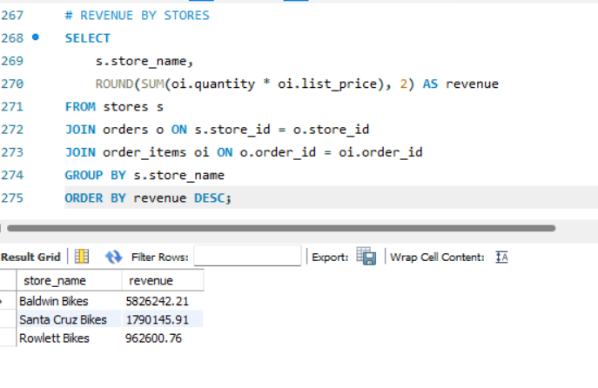

MONTHLY SALES TREND (by years)

SELECT
YEAR(STR_TO_DATE(order_date, '%Y-%m-%d')) AS year,
MONTH(STR_TO_DATE(order_date, '%Y-%m-%d')) AS month,
ROUND(SUM(oi.quantity * oi.list_price), 2) AS revenue
FROM orders o
JOIN order_items oi ON o.order_id = oi.order_id
GROUP BY year, month
ORDER BY year;

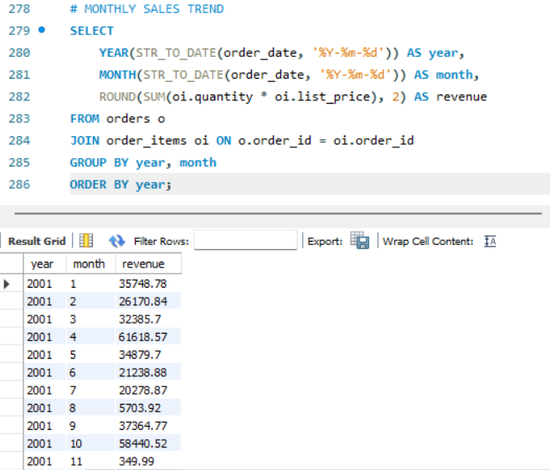

DAILY SALES TREND

SELECT
o.order_date,
ROUND(SUM(oi.quantity * oi.list_price), 2) AS revenue
FROM orders o
JOIN order_items oi ON o.order_id = oi.order_id
GROUP BY o.order_date
ORDER BY o.order_date;

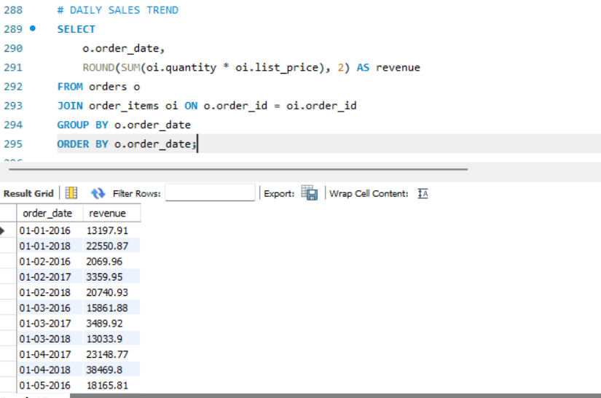

CITY WITH MOST CUSTOMERS

SELECT
city,
COUNT(*) AS total_customers
FROM customer
GROUP BY city
ORDER BY total_customers DESC
LIMIT 1;

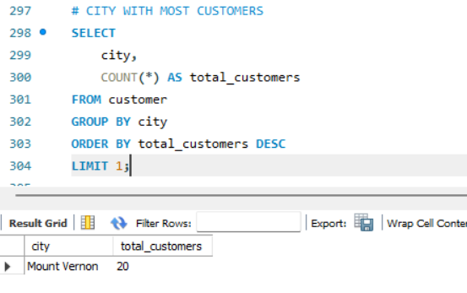

STATE WITH MORE CUSTOMER

SELECT
state,
COUNT(*) AS total_customers
FROM customer
GROUP BY state
ORDER BY total_customers DESC
LIMIT 1;

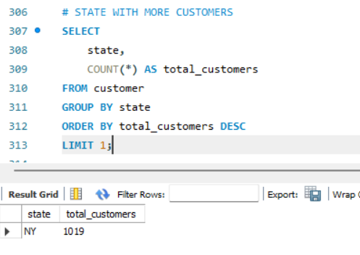

BEST SELLING STORE

SELECT
s.store_name,
ROUND(SUM(oi.quantity * oi.list_price), 2) AS revenue
FROM stores s
JOIN orders o ON s.store_id = o.store_id
JOIN order_items oi ON o.order_id = oi.order_id
GROUP BY s.store_name
ORDER BY revenue DESC
LIMIT 1;
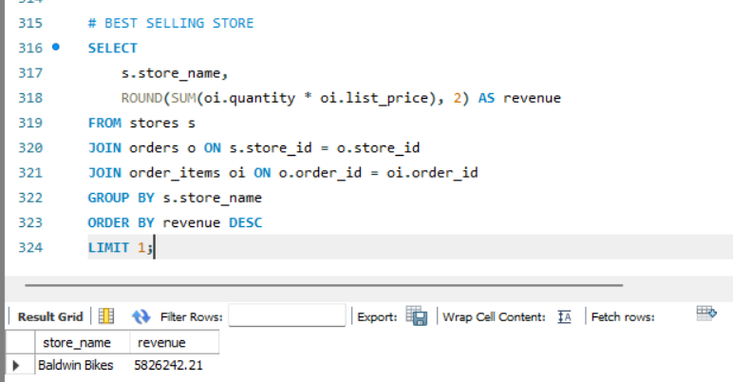

LEAST SELLING STORE

SELECT
s.store_name,
ROUND(SUM(oi.quantity * oi.list_price), 2) AS revenue
FROM stores s
JOIN orders o ON s.store_id = o.store_id
JOIN order_items oi ON o.order_id = oi.order_id
GROUP BY s.store_name
ORDER BY revenue ASC
LIMIT 1;
